

Human Computer Interactions

(5CS020)

Usability Report on Web Applications

Report Writing

Student Id : 2329816

Student Name : Swasthani Shrestha

Group : L5CG14

Lecturer : Mr. Pramin Joshi

Tutor : Ms. Nerisha Shrestha

Word Count : 1485

Submitted on : 22nd March, 2024

**Acknowledgement**

First off, I want to express my sincere thanks to Herald College for providing me with this incredible opportunity to showcase my research and report writing skills. I’m immensely thankful for the dedication and effort my lecturers and tutors have invested in preparing us for this project. Working under the guidance of my teachers has been an honor, and I feel truly grateful. Lastly, a big shoutout to my friends, whose unwavering support has been crucial in completing this project.

**Abstract**

The documented report contains concepts related usability in web interface, its application, and focuses specifically the role it plays in web interface design. To qualify as usable, a design must follow certain principles, which are documented in this report through the analysis of two wen designs. The guidelines proposed by Ben Schneiderman and Jacob Neilsen, which are widely regarded by developers for crafting user-friendly UI UX designs, are central to this discussion.

**Table of Contents**

1. Introduction: 1

1.1. Usability 1

1.2 Importance of Usability 1

2. Literature Review: 2

2.1 Based web design and usability guidelines 2

2.2 Usability guidelines for usable user interface 3

3. Examples of Web Application 4

3.1 Focusmate 4

3.2 Amazon 5

4. Analysis: 6

4.1 Application of 8 Golden rules in web applications: 6

4.1.2. Enable frequent users to use shortcuts: 8

4.1.3 Design dialog to yield closure: 10

4.1.4 Offer simple error handling: 12

4.1.5 Permit easy reversal of actions: 14

4.1.6 Support internal locus of control 16

4.1.7 Reduce short - term memory load 18

4.1.8 Offer informative feedback 20

4.2 Jacob Neilson’s 10 Heuristics 22

4.2.1 Visibility of system status 22

4.2.2 User control and freedom 23

4.2.3 Consistency and standards 23

4.2.4 Error prevention 24

4.2.5 Recognition rather than recall 26

4.2.6 Flexibility and efficiency of use 26

4.2.7 Aesthetic and minimalist design 26

4.2.8 Help users recognize, diagnose, and recover from errors 27

4.2.9 Help and documentation 27

5. Conclusion 29

6. References 30

7. Appendix 31

32

**Table of Figures**

Figure 1: Focusmate 4

Figure 2: Amazon 5

Figure 3: Consistent dashboard design in Focusmate 6

Figure 4: Consistent design in Amazon 7

Figure 5: Shortcut usage in Focusmate 8

Figure 6: Shortcut usage in Amazon 9

Figure 7: Informative dialog box to yield closure 10

Figure 8: Informative feedback to yield closure in Amazon 11

Figure 9: Error handling in Focusmate 12

Figure 10: Error handling in Amazon 13

Figure 11: Feature showing reversible action in Focusmate 14

Figure 12: Feature showing reversible action in Amazon 15

Figure 13: Internal locus of control given to users in Focusmate 16

Figure 14: : Internal locus of control given to users in Amazon 17

Figure 15: Feature enabling users to reduce memory load in Focusmate 18

Figure 16: Feature enabling users to reduce memory load in Amazon 19

Figure 17: Informative feedback by the system in Focusmate 20

Figure 18: Informative feedback by the system in Amazon 21

Figure 19: : Icon usage in Focusmate showing the match between system and real world 22

Figure 20: Icon usage in Amazon showing the match between system and real world 23

Figure 21: Error prevention in Focusmate 24

Figure 22: Error prevention in Amazon 25

Figure 23: Aesthetic and minimalistic design of Focusmate 26

Figure 24: Aesthetic and minimalistic design of Amazon 27

Figure 25: Help and Documentation of Focusmate 28

Figure 26: Help and Documentation of Amazon 28

Figure 27: Landing Page 32

Figure 28: Feature 1 33

Figure 29: Feature 2 34

Figure 30: Feature 3 35

Figure 31: Feature 4 36

Figure 32: Feature 5 37

Figure 33: Setting page 38

Figure 34: Profile page 39

# Introduction:

## 1.1. Usability

Usability simply refers to the capability of a system to be usable. Generally, it means the way a system can interact with the users to provide user’s immediate needs and context with ease and satisfaction. This definition generates from the idea of the human behaviour and psychology. Humans by nature crave comfort and want to achieve any amount of success in any work with the bare minimalistic effort and the same applies while designing an interface. One of the key factors of usability is to optimize the user experience that is designing website in such a way that it encourages effective and efficient human-computer interactions Simply, if a system is easy to use and completes any task of the user with low effort and no errors then a system is said to be usable.

## 1.2 Importance of Usability

While designing a web interface, the designers need to consider the main objective of usability i.e. focusing on reducing the user’s workload by making the use of the system’s abilities. The design should strive for simplicity, should be aesthetically pleasing, accessible and it should maintain clarity while ensuring the goals of the website. If the website application is hard to navigate and users lose their track due to a cluttered design, it might be frustrating for the users which can affect the overall success of the web application.

# Literature Review:

## 2.1 Based Web Design and Usability Guidelines

To sketch an interface that meets user’s satisfaction and is both easy to navigate and user-friendly, it should include navigation bars with predictable patterns, allowing users to effortlessly move through features without confusion. The interface design should be minimalistic to reduce clutter and should be visually appealing, making it intuitive. Consistency in design elements and their placement develops user familiarity and comfortability.

These principles not only help minimize human effort for successful completion of tasks but also creates an environment for users to feel comfortable and engaged. Additionally, prioritizing accessibility and inclusivity by maintaining the standards set by Web Content Accessibility Guidelines(WCAG) which ensures that all the user’s requirements are met and satisfied. (Leavitt & Shneiderman, 2015)

## 2.2 Usability guidelines for usable user interface

Designing usable interface requires implementing the eight golden rules of Schneiderman and ten heuristics of usability by Jacob Neilson. These principles emphasize interface consistency, shortcut keys for frequent users, and other strategies. Past Studies show users prefer web applications with familiar, consistent patterns. Clearly setting and communicating design goals to the target audience also aligns the application more closely with user expectations, enhancing overall usability.

Instant feedback on task success or failure and loading times reduces user frustration and confusion. Shortcuts makes tasks easier for regular users. Immediate action feedback, along with navigation aids like breadcrumbs and mega menus, enhance user experience by improving system navigation and tracking usage history, making interactions smoother and more intuitive. (Mazumder & Das, 2014)

# Examples of Web Application

## 3.1 Focusmate

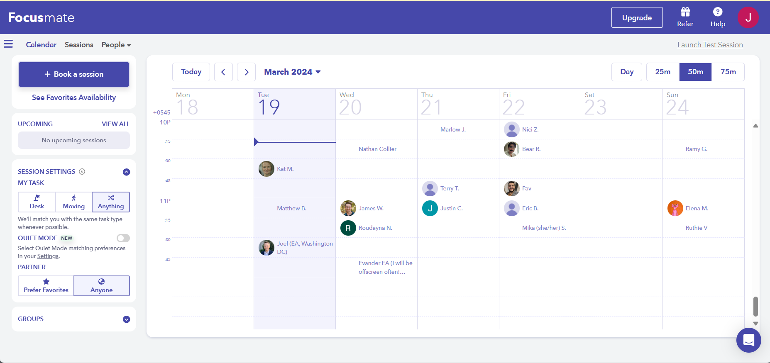

Figure 1: Focusmate

Focusmate is a web-based application that focuses on “getting things done”. This productivity-based application helps users to schedule meetings for virtual coworking.

## 3.2 Amazon

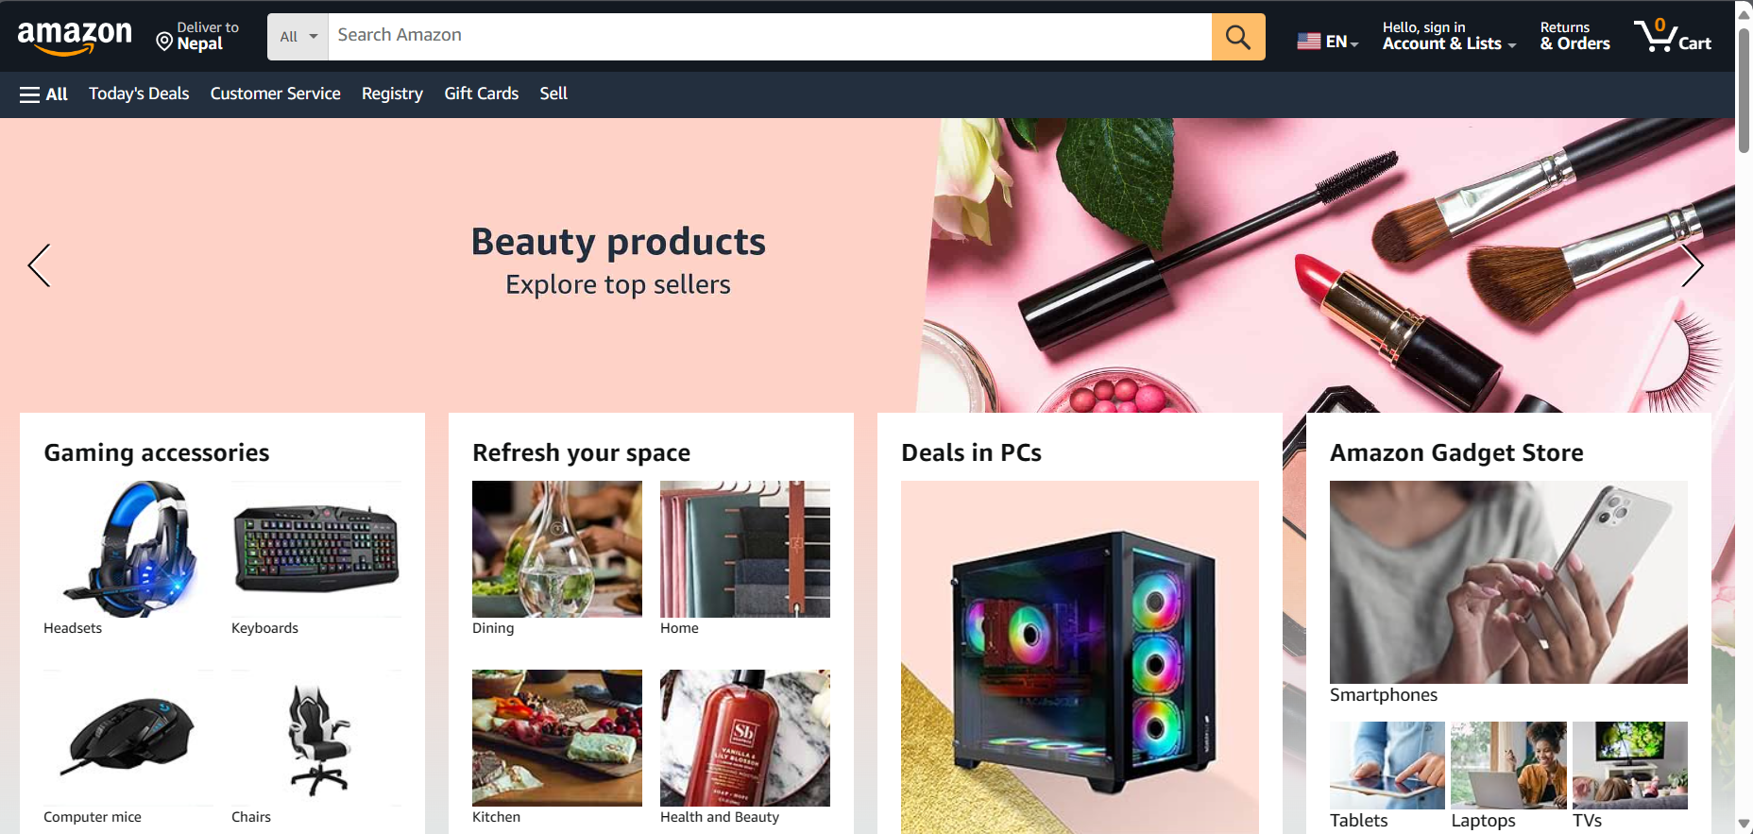

Figure 2: Amazon

Amazon is an ecommerce web application that helps users to purchase products and services from around the globe.

# Analysis:

## Application of 8 Golden rules in web applications:

4.1.1 Strive for consistency:



Figure 3: Consistent dashboard design in Focusmate

Focusmate web application has a consistent design and uses simple layout to help users to navigate the system.

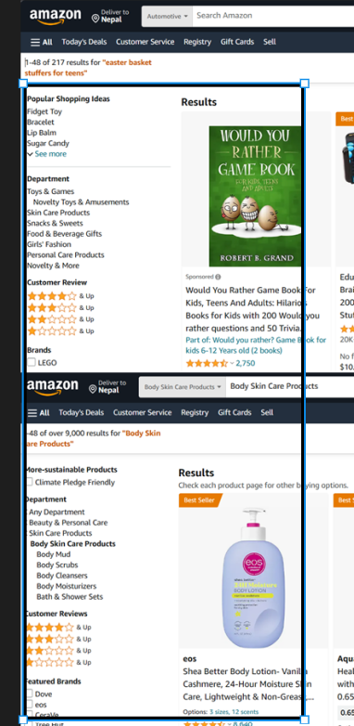

Figure 4: Consistent design in Amazon

The layout in Amazon is consistent, informative and allows effective navigation. It has dropdown menu to search for products in categories.

### 4.1.2. Enable frequent users to use shortcuts:

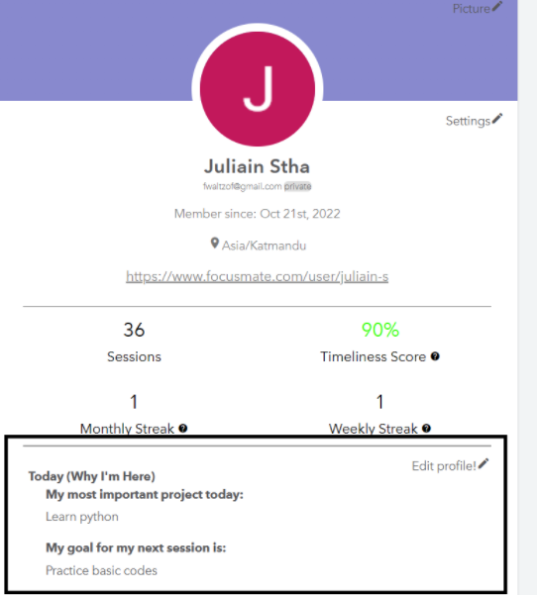

Figure 5: Shortcut usage in Focusmate

The system offers numerous features, including shortcuts. For session bookings, users can set a fixed goal without the need to specify it for every session.

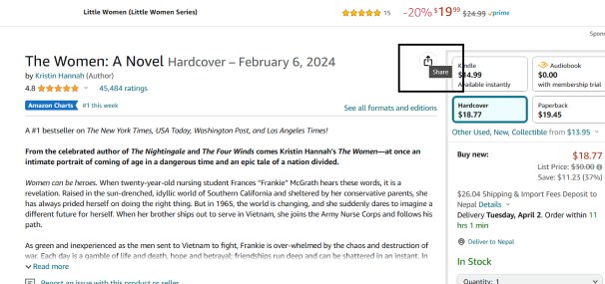

Figure 6: Shortcut usage in Amazon

On Amazon, the share button allows users to re1fer products to others without needing to remember the product details for referral.

### 4.1.3 Design dialog to yield closure:

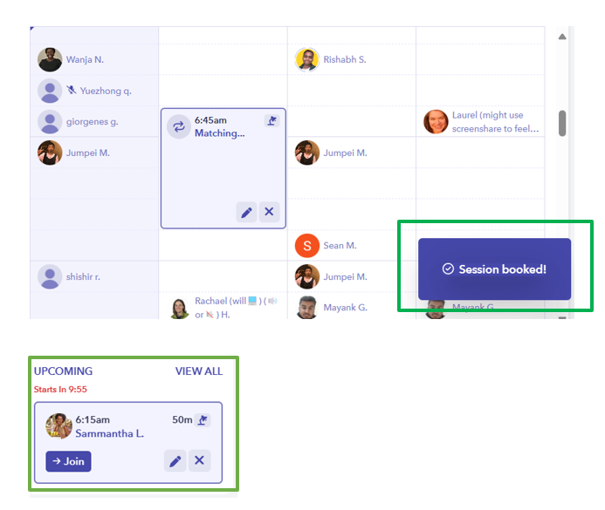

Figure 7: Informative dialog box to yield closure

Focusmate enables users to book sessions and communicates the success or failure of these bookings via dialog boxes.

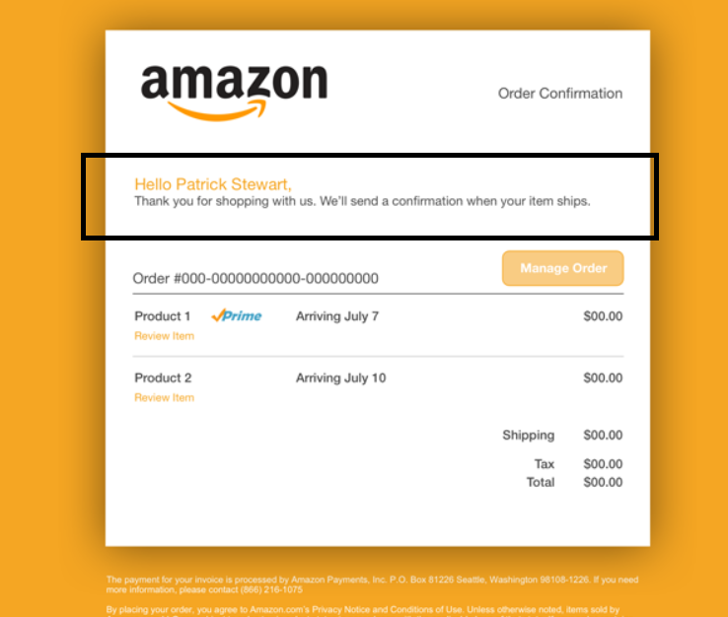

Figure 8: Informative feedback to yield closure in Amazon

After the order is confirmed, the users are informed about their order details by redirecting them to a next page.

### 4.1.4 Offer simple error handling:

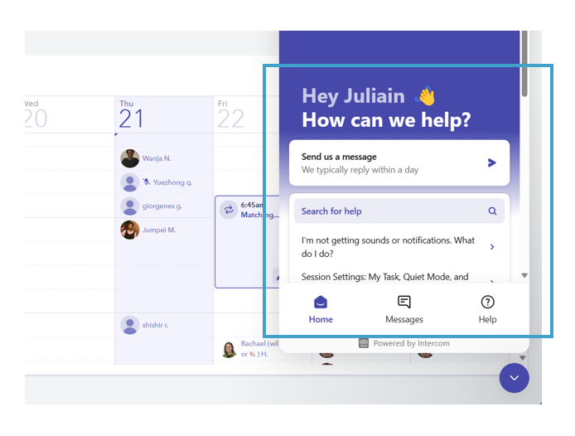

Figure 9: Error handling in Focusmate

If a user encounters any error in the system, they can simply go to the dropdown button in the dashboard to solve the problem and get solutions.

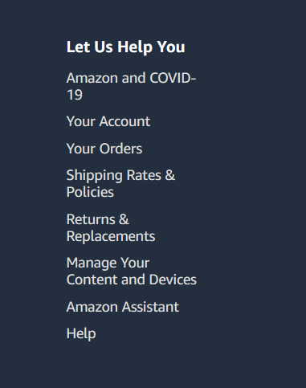

Figure 10: Error handling in Amazon

In Amazon, if a user gets confused in any of the processes while using the system, they offer simple error handling which can be accessed from the app itself.

### 4.1.5 Permit easy reversal of actions:

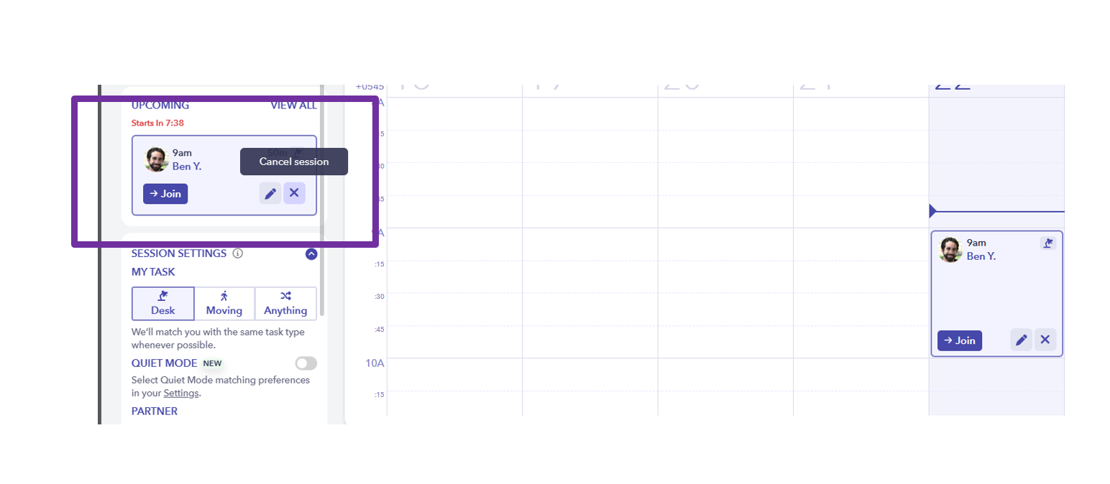

Figure 11: Feature showing reversible action in Focusmate

If a session is accidentally canceled, users can easily reverse this action by accessing their session history.

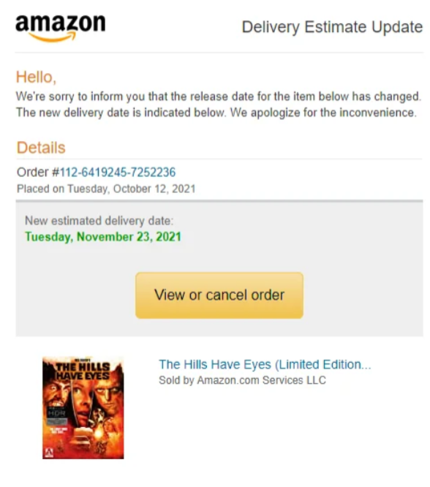

Figure 12: Feature showing reversible action in Amazon

Amazon enables users to cancel orders through interactive elements, offering flexibility after the purchase is made.

### 4.1.6 Support internal locus of control

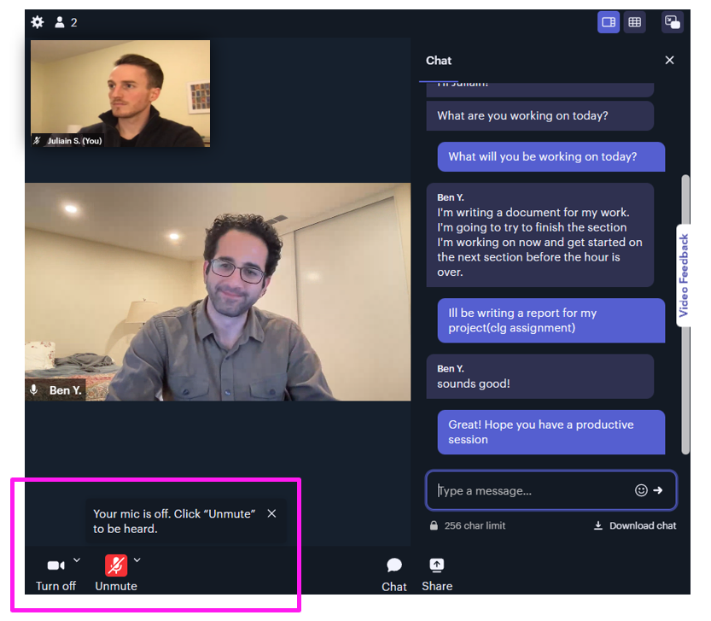

Figure 13: Internal locus of control given to users in Focusmate

Focusmate permits users to enable and disable certain features to let the users have control over the system.

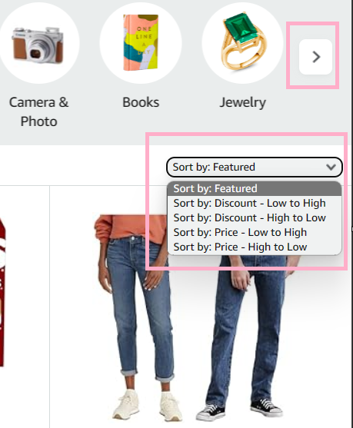

Figure 14: : Internal locus of control given to users in Amazon

Amazon’s search function allows users to find products by preferences, giving them a sense of control over the system.

### 4.1.7 Reduce short - term memory load

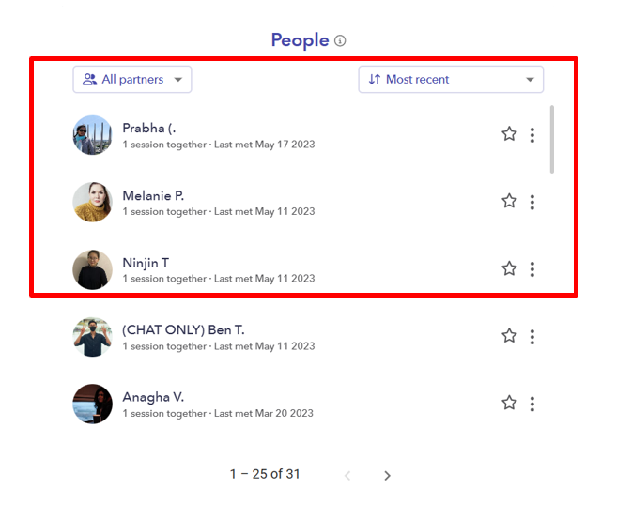

Figure 15: Feature enabling users to reduce memory load in Focusmate

Users can add favorite partners to a list from their history after sessions, simplifying future booking with preferred partners.

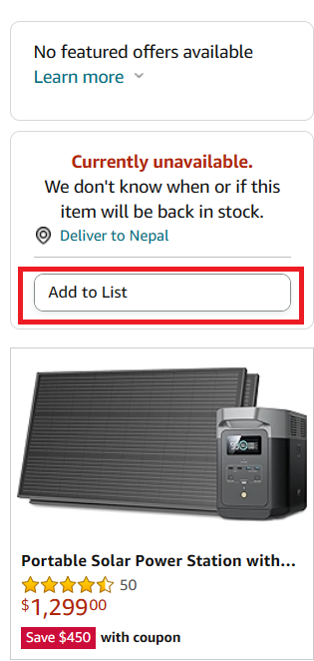

Figure 16: Feature enabling users to reduce memory load in Amazon

Users can save items to a list post-browsing, making later viewing and purchasing more manageable.

### 4.1.8 Offer informative feedback

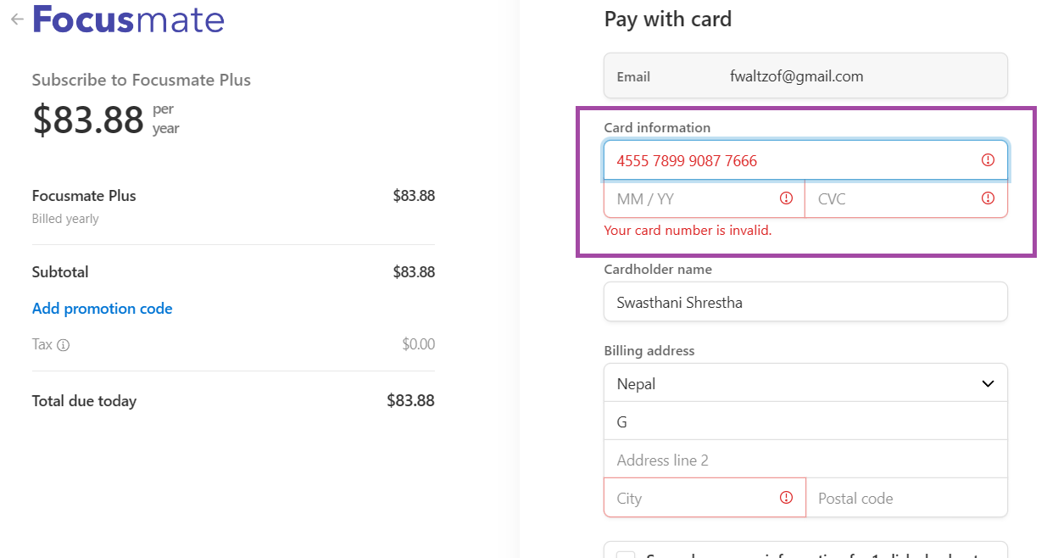

Figure 17: Informative feedback by the system in Focusmate

Feedback for form errors reminds users to correct invalid information.

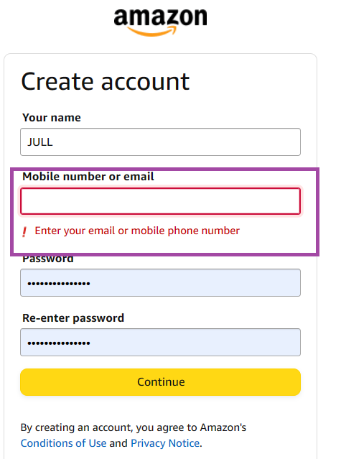

Figure 18: Informative feedback by the system in Amazon

When the user enters wrong credentials, feedback is given to the user from the system.

## Jacob Neilson’s 10 Heuristics

### 4.2.1 Visibility of system status

This rule can be explained by Schneiderman’s two rules which are mentioned in: 4.1.3. and 4.1.8.

### 4.2.2 Match between system and the real world

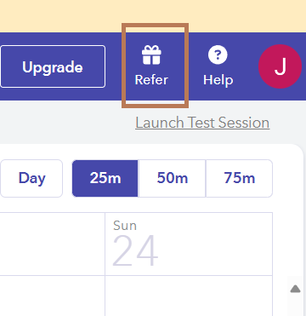

Figure 19: : Icon usage in Focusmate shows familiarity

The ‘gift’ icon symbolizes referral rewards, mirroring real-life gifts to boost user familiarity with the system.



Figure 20: Icon usage in Amazon shows familiarity

The ‘cart’ icon used in this system mimics a real-world shopping cart, making it familiar to users, especially on an e-commerce site like Amazon.

### 4.2.3 User control and freedom

This rule can be explained by Schneiderman’s two rules which are mentioned in: 4.1.5. and 4.1.6.

### 4.2.4 Consistency and standards

This rule can be explained by Schneiderman’s one of the rules mentioned in: 4.1.1.

### 4.2.5 Error prevention

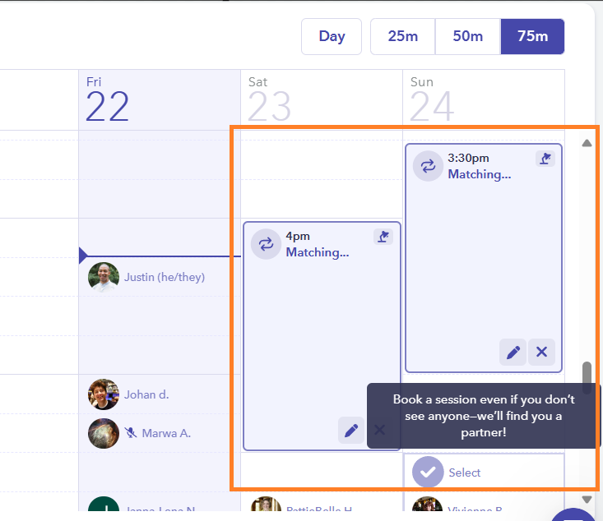

Figure 21: Error prevention in Focusmate

The system alerts users to existing bookings when they try to book a session, preventing double booking as a form of error prevention.

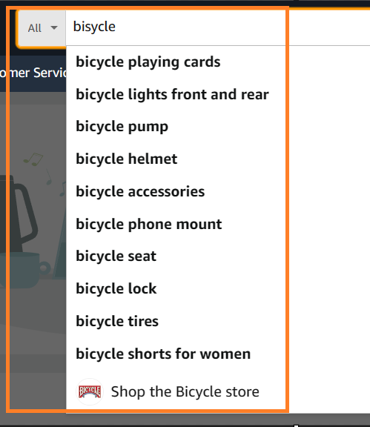

Figure 22: Error prevention in Amazon

Amazon prevents errors by suggesting similar products when a user misspells a product name, aiding in correction.

### 4.2.6 Recognition rather than recall

This rule can be explained by Schneiderman’s two rules which are mentioned in: 4.1.7.

### 4.2.7 Flexibility and efficiency of use

This rule can be explained by Schneiderman’s two rules which are mentioned in: 4.1.2. and 4.1.5.

### 4.2.8 Aesthetic and minimalist design

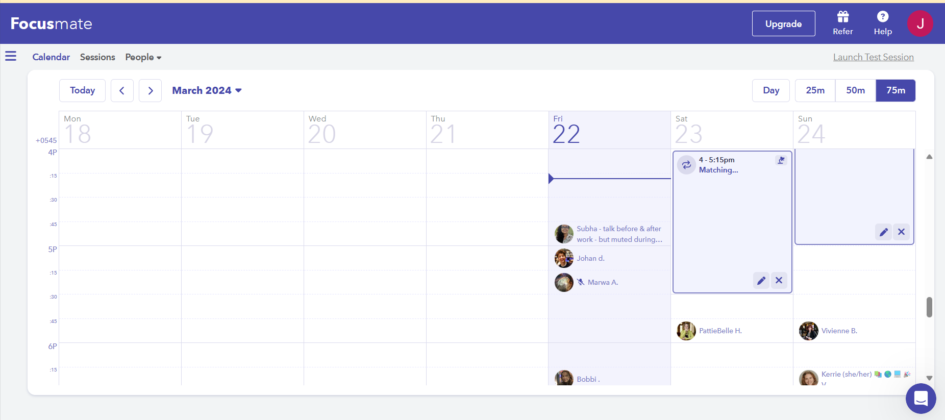

Figure 23: Aesthetic and minimalistic design of Focusmate

Focusmate’s minimalist design and structured layout enhance visual appeal and user satisfaction by appearing less overwhelming.

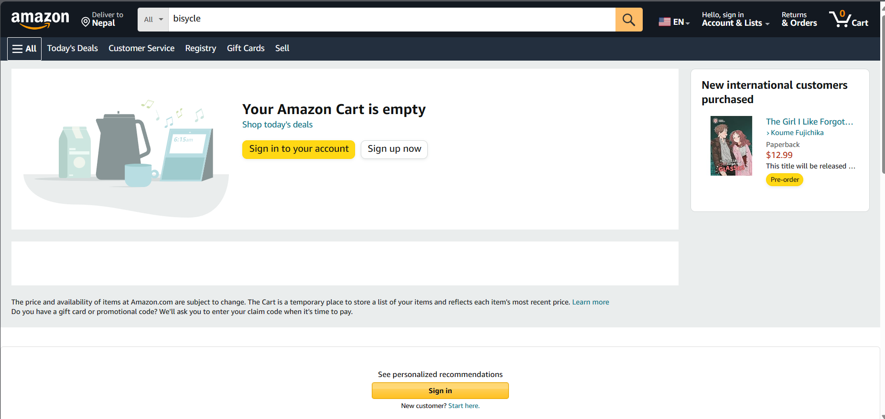

Figure 24: Aesthetic and minimalistic design of Amazon

The minimalistic and aesthetically pleasing design of Amazon doesn’t overwhelm users while using the system.

### 4.2.9 Help users recognize, diagnose, and recover from errors

This rule can be explained by Schneiderman’s one of the rules which is mentioned in: 4.1.4.

### 4.2.10 Help and documentation

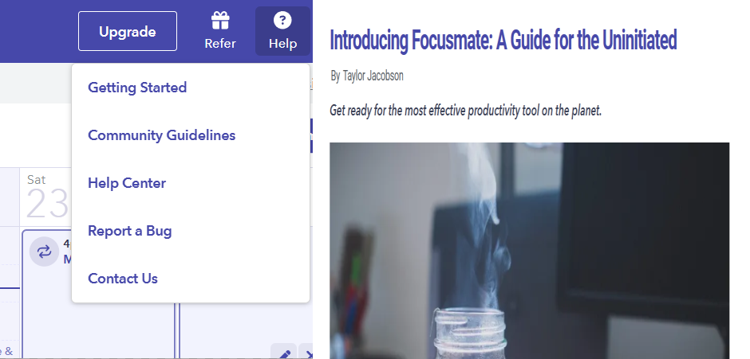

Figure 25: Help and Documentation of Focusmate

Focusmate offers comprehensive help and documentation, including direct contact options for new users seeking assistance.

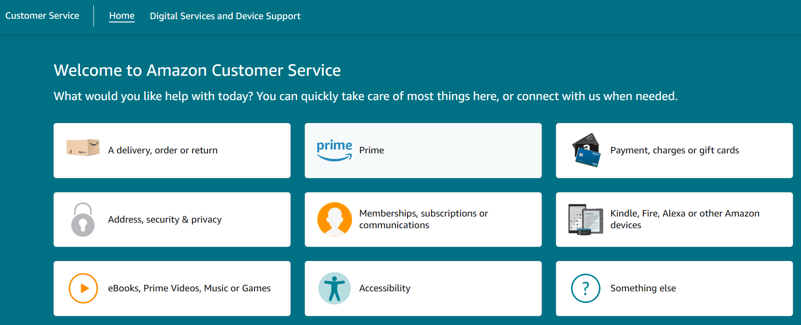

Figure 26: Help and Documentation of Amazon

Amazon enhances user satisfaction with customer service and well documented resources, aiding new users in resolving issues or confusion.

# Conclusion

Through this report, it is clear that Schneiderman and Neilson’s usability rules are crucial for crafting highly usable systems that enhance user satisfaction. This report highlights how aligning to these guidelines significantly improves user-friendliness.   
An analysis of Focusmate and Amazon’s web applications based on these usability principles demonstrated their effectiveness in creating systems that meet user needs. The documented report underscores the importance of these rules in designing intuitive UI/UX, prioritizing user demands and preferences.

# References

Leavitt, M. O., & Shneiderman, B. (2015). *Based web design & usability guidelines.* Retrieved from https://d1wqtxts1xzle7.cloudfront.net/57528614/guidelines_book-libre.pdf?1539034689=&response-content-disposition=inline%3B+filename%3DResearch_Based_Web_Design_and_Usability.pdf&Expires=1710869439&Signature=gfJ90Ha8ec3UamwhhqB3Fx2ivqTN71Ods2U9aOqt~LLfsCh

Mazumder, F. K., & Das, U. K. (2014). *USABILITY GUIDELINES FOR USABLE USER INTERFACE.* Dhaka: International Journal of Research in Engineering and Technology.

# Appendix

**7.1.** Wireframe

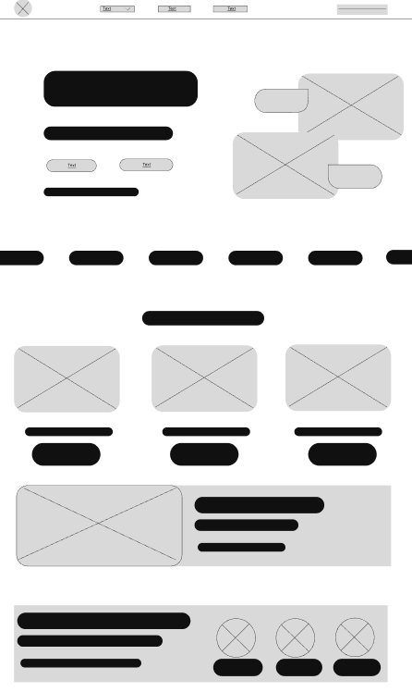

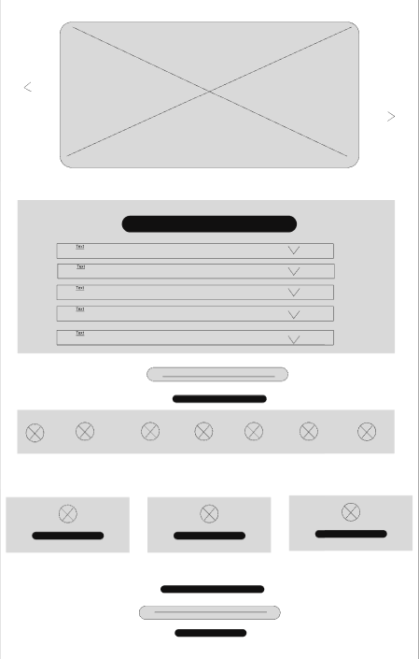

# 

Figure 27: Landing Page

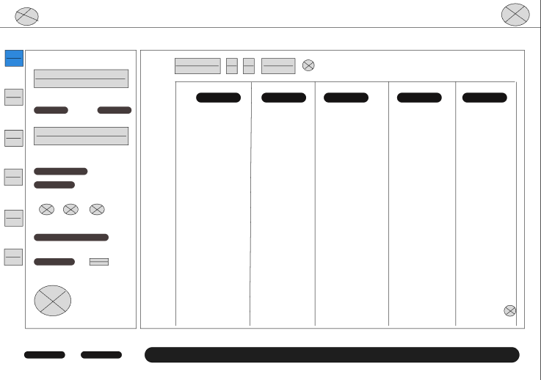

Figure 28: Feature 1

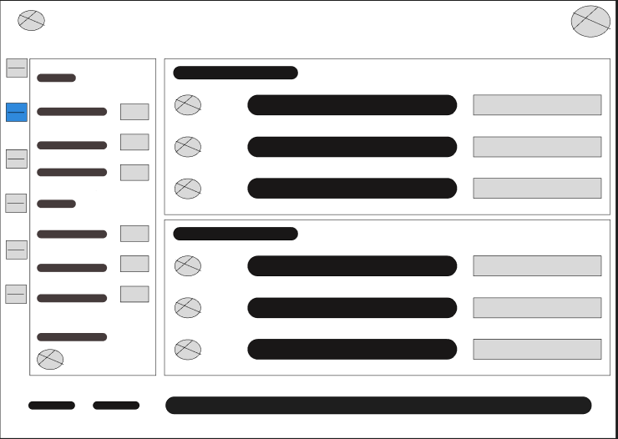

Figure 29: Feature 2

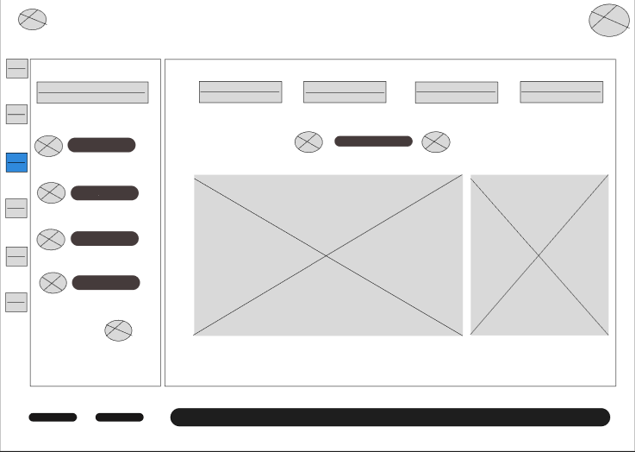

Figure 30: Feature 3

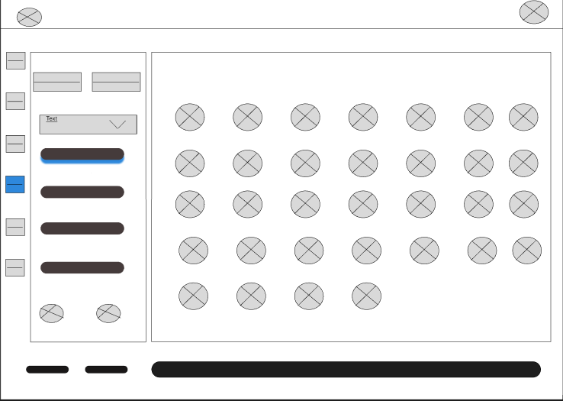

Figure 31: Feature 4

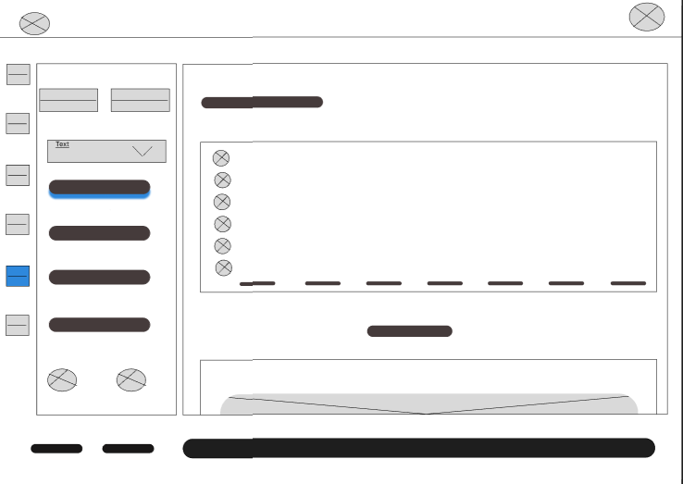

Figure 32: Feature 5

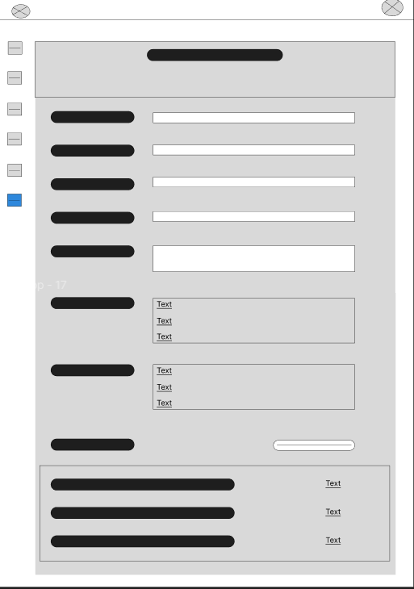

Figure 33: Setting page

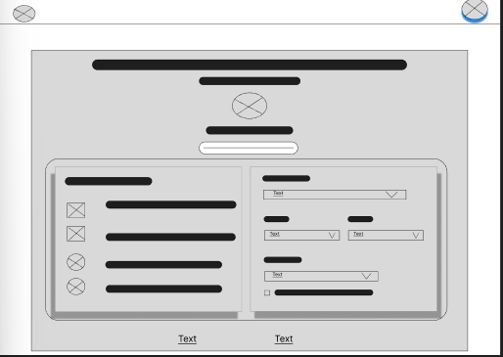

Figure 34: Profile page